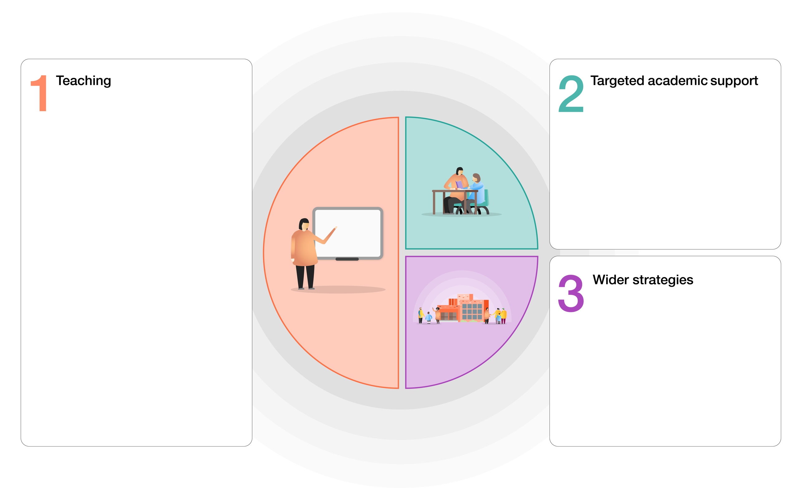
Redhill Primary Academy

To enable improved access to the curriculum:
- Numeracy intervention, supporting those identified children in reinforcing their understanding of basic maths skills and application of number.
- Staff within phases are trained and they are able to deliver intervention confidently
- Same-day in-class intervention, pre and post lessons to plug gaps
- Teacher led targeted group teaching for Year 2, Year 5 and Year 6 pupils, using catch up funding
- Identified children provided with after school tuition to ensure the attainment of those identified children improves and effect of lockdown is becoming negated. NTP programme for Year 5, provider?
- 1-to-1 and small group tuition to increase rates of reading fluency, to comprehend reading better as a result of being able to read at pace without spending their working memory decoding.
- NELI, socially speaking intervention to help develop language skills.
Implement a 12-week curriculum cycle to place retrieval practice, formative assessment and rich summative assessment at the top of the agenda.
Frequent low-stakes testing to ensure all students, and in particular disadvantaged students, experience success and celebrate the acquisition of knowledge.
Maintain our existing CPD focus on developing metacognition and the quality of teacher modelling and explanation.
Quality First Teaching supported by evidence- informed CPD for teachers and support staff.
A broad and engaging curriculum that focuses on vocabulary acquisition.
Whole-class reading approach in KS2 underpinned by clearly defined formative assessment practices and use of VIPERS.
Focus on critical aspects we need to teach well. A package of home learning via Teams ensuring we focus on basic skills.
Microsoft Teams used as a platform for homework and live lessons. Feedback on tasks given via face-to-face learning or through the online platform.
Frequent phone calls to check on the progress of home learning and the wellbeing of both children and families.
High focus on phonics and application
Use of Back on Track assessments through AFL activities and used to support those learners who are not able to access their year curriculum.
The foundation subject will be planned with increasing detail and consideration for how pre-requisite knowledge will be taught alongside new learning so that knowledge gaps can be reduced.

To enable access to a blended learning model:
- Provide ongoing technical support.
- Purchase of new laptops to ensure our most vulnerable pupils have priority access to IT equipment so they can access classroom teaching and online materials.
- Ensure pastoral contact home for disadvantaged students also identifies barriers to engagement due to technology or a lack of other forms of support.
- Use coaching to ensure teachers are focused on closing gaps for disadvantaged students that would potentially be greater in a blended learning environment.
- Delivery of food parcels or vouchers in school holidays.
- Provide parents with additional support materials to support learning at home – CGP materials.

Identified impact of lockdown
Maths | Specific content has been missed, leading to gaps in learning and stalled sequencing of journeys. Children still have an appetite for maths and lockdown has not affected their attitudes however they are quite simply, ‘behind’. Recall of basic skills has suffered – some children are not able to recall addition facts, times tables and have forgotten once taught calculation strategies. This is reflected in assessments.
Writing | Children haven’t necessarily missed ‘units’ of learning in the same way as Maths, however they have lost essential practising of writing skills. GPS specific knowledge has suffered, leading to lack of fluency in writing. Those who have maintained writing throughout lockdown are less affected; however, those who evidently didn’t write much have had to work additionally hard on writing stamina and improving their motivation due to the lack of fluency in their ability to write.
Reading | Children accessed reading during lockdown more than any other subject. This is something that was more accessible for families and required less teacher input. However, children are less fluent in their reading and the gap between those children that read widely and those children who don’t is now increasingly wide. Some of the bottom 20% of readers have been disproportionately affected
Non-core | There are gaps in knowledge –units of work delivered by remote learning, have resulted in some children less able to access pre-requisite knowledge when learning something new and are therefore less likely to make connections between concepts and themes throughout the curriculum. Children have also missed out on the curriculum experiences e.g. trips, visitors and powerful curriculum moments.
 | Subject area of concern | % of year group covering year group objectives | Back on track/Catch up methods being used, including interventions and assessments. | Impact to date including data
Reception | Writing  Reading | 80% working within 30- 50 D / S or above  68% working with 30-50 D/S or above | Differentiated planned focused activities for writing/literacy – high emphasis on fine and gross motor.  Adult support to encourage use of phonics and early writing.  High focus on phonics and application.  Funky fingers starting for key children as well as whole class.  1:1 reading initially – continued with bottom 20%  Interventions for fine motor, reading and phonics.  NELI intervention to support the development of language for key hildrne identified. Sentence booster – with Teacher to support those children who are struggling to apply skills independently to write a sentence. | % Oct Reading Writing Maths GPS  ARE 77 63 77  GDS 38 29 38  % End of Year Prediction  ARE 78 78 80  GDS 20 18 20
Year 1 | Writing/SPAG (big push on non-negotiables)  Application of phonics into writing | Maths 81% accessing Y1 (11 off)  Reading 81% (11 0ff)  Writing 80% (12 off)  59 children in cohort | Interventions in maths and phonics.  Handwriting intervention  Probe to develop on sight vocab and sounds.  Bottom 20% reading 1:1 reading sessions and small group in addition to GR.  Group size in phonics small to provide more targeted teaching (receiving 2 daily sessions).  Socially speaking intervention to help develop language skills.  Assembly intervention – basic sentence construction.  Differentiated planned focused activities for writing and maths.  End of phase assessments for phonics  Phonics half termly screening  Maths planning linked to shown gaps in pre assessment.  Pre teaching on new concepts  Individual targets in Maths and Literacy. | % Oct Reading Writing Maths GPS  ARE 78 77 82 77  GDS 18 15 13 14  % End of Year Prediction  ARE 83 81 83 81  GDS 23 20 20 20
Year 2 | Writing and SPAG  Reading – comprehension and on sight vocabulary.  Phonic application | Maths 83% (10 off)  Reading 78% (13 off)  Writing 78% (13 off)  60 in cohort | 4x weekly phonics booster groups in the mornings with TA  2 x weekly Phonics intervention in afternoons with TA  4x weekly phonics booster groups in the mornings with additional teacher  Additional 1:1 reading for bottom 20%.  Back on track embedded into maths and literacy lessons where appropriate.  Phonics assessments being carried out to help plug gaps.  Once NFER complete will be used to inform intervention.  Maths and English Back on Track resources being used as Afl  Focused handwriting sessions with additional teacher  Targeted writing sessions with additional teacher | % Oct Reading Writing Maths GPS  ARE 73 70 76 61  GDS 22 15 18 16  % End of Year Prediction  ARE 78 76 78 64  GDS 26 22 26 22
Year 3 | Writing and spelling.  Maths | Writing 67% (20 off)  Maths 70% (18 off)  Reading 67% (20 off)  60 in cohort | Spelling- have used the back on track assessments going back to previous year groups. This has informed differentiated spelling lessons and homework. Have gone back to Y1/2 words with key phonemes. No one is following the Year 3 spelling curriculum. Adding in common exception words from Y1/2 being added onto spelling lists.  Phonics daily for those children who have not passed phonics screening check.  1:1 daily reading for the bottom 20%.  Spelling given high focus through marking.  Maths and English back on track materials used as AfL activities and used to support those learners who are not able to access Y3 curriculum. Interventions as and when to mop up children not meeting expectations.  Reading and writing through the wider curriculum wherever possible.  Additional handwriting and mental maths in the afternoon.  Mental maths session weekly.  Small group teacher and/or TA focus for those children who need catch in every lesson.  Differentiated planned focused activities for reading, writing and maths.  Maths planning linked to shown gaps in pre assessment.  Pre teaching on new concepts  Individual targets in Maths and Literacy. | % Oct Reading Writing Maths GPS  ARE 75 66 73 62  GDS 32 15 22 20  % End of Year Prediction  ARE 85 72 83 73  GDS 42 27 38 28
Year 4 | Writing and spelling. | Writing 64% (22 off)  Spag 67% (20 off)  Reading 80 % (12 off)  Maths 74% (16 off) | Spelling-have used the back on track assessments going back to previous year groups. This has informed differentiated spelling lessons and homework.  Maths resources used more for lower ability groups as a scaffold to support intervention or catch up. Also used as a diagnostic tool to assess gaps.  Writing- focusing on the key objectives identified in the back on track materials. Maximising writing opportunities e.g. if the literacy lesson has a speaking and listening focus put in the afternoon and do a writing focus in geography or science in the morning. Plenty of opportunity for modelled, supported and guided writing. Additional handwriting in the afternoon. Focus on spelling in spag inputs.  Daily reading with children not on track.  Continue daily reading with lowest 20%. Phonics x3 per week with children who have not passed screening check.  Spelling Precision Teaching targeting Y1/2 common exception words and continue SNIPP intervention.  Maths targeted TT Rockstars additional support for times tables..Power of 2. Additional pre and post tutoring as needed. Use maths back on track to support intervention in maths as we move to areas which will be less secure e.g. Multiplication, division and fractions.  Continue to model and scaffold writing regularly across different subject areas.  SPAG afternoon session to continue with focus on gaps identified from NFER | % Oct Reading Writing Maths GPS  ARE 85 71 83 80  GDS 30 17 25 28  % End of Year Prediction  ARE 87 72 83 82  GDS 33 20 26 31
Year 5 | Reading  Writing/spelling  Maths | 67% 13 TH + 13 VK  67% 13 TH + 13 VK  66% 10 TH + 10 VK | Guided groups within sessions, daily readers.  Guided groups within sessions, schubi card writing, word wasp, SNIP spelling  Back on Track sessions in addition to daily maths lessons and daily mental maths, power of 2.  Reading  Guided groups within sessions, daily reading aloud for those not on track.  Guided reading daily- Teacher focus group.  Individual reading with an adult.  Differentiated reading groups and specific focus on retrieval.  Literacy lessons to support the reading and sequencing aspect etc  Reading throughout the curriculum wherever possible  Whole class story time  Writing/spelling  Guided groups within sessions, schubi card writing, word wasp, SNIP spelling.  Use of recording story boards to support oral rehearsal  Children reminded to re-read what they have written.  Differentiated Spelling  WASP  Use of laptops  Snip  Homophone prompt sheets in books.  Handwriting prompt sheets in books  Use of clicker  Maths  Back on Track sessions in addition to daily maths lessons and daily mental maths, power of 2.  Daily focus group for fluent in 5  Follow Ups  · mental arithmetic sessions  - fluent in 5 resources.  Revisited key skills from lessons  Practical resources for Maths (Numicon, Multi-link etc  Revision of all 4 operations.  Pre and post teaching when necessary when teaching new concepts. | % Oct Reading Writing Maths GPS  ARE 71 65 78 73  GDS 25 17 20 17  % End of Year Prediction  ARE 85 77 85 78  GDS 42 30 35 32
Year 6 | Reading  Writing/spelling  Maths | 80% 6 AC + 6 LW  75% 8 AC + 7 LW  78% 6 AC + 7 LW | Reading  Early assessment administered in Year 6 to identify and address gaps through adapted planning and teaching.  Huge focus on improving the quantity and quality of reading at home: daily/weekly checking of reading records, high expectations for comments from children and parents, weekly rewards in the form of house points for reading effort at home.  Guided groups within lessons, reading interventions led by class teachers for those not on track, daily reading aloud for those not on track.  Book banded book and personal reading book for those not on track.  Parents asked to listen to children not on track 3x per week.  All parents asked to listen to children read once per week.  Reading log used to track children’s personal reading choices and ensure challenge.  Y6 recommended book list sent out to parents following parent consultations.  Writing/spelling  Focusing on the key objectives from Back on Track materials whilst challenging the more able writers with differentiated targets and activities.  Huge focus on proof-reading in order to address gaps from previous year groups.  Guided groups within sessions.  Spelling review and catch up sessions.  SNIP spelling intervention for children with SEND.  Additional daily grammar/punctuation/spelling sessions.  Plentiful opportunities for modelled, shared and guided writing.  Personal weekly spellings for low-scoring spellers in autumn assessment.  Personal spelling dictionaries used in class.  Re-teach and re-test for all children scoring less than 8/10 in weekly spelling test.  Maths  Huge focus on mental maths/arithmetic: daily sessions in addition to maths lessons involving teacher modelling and enabling constant revisit and review in order to master fundamental strategies and calculations.  Back on Track assessments administered and additional intervention for those not secure in previous year group’s concepts.  Power of 2 intervention for children with SEND.  Post-assessments used to inform intervention groups.  Guided groups within sessions.  Increased focus on learning times tables at home incentivised by house points.  TTRS used as EMA for targeted children to foster interest.  Guided groups within sessions, daily readers.  Guided groups within sessions, spelling review and catch up sessions, SNIP spelling.  Maths review and catch up sessions in addition to daily maths lessons and daily mental maths. | % Oct Reading Writing Maths GPS  ARE 81 71 74 67  GDS 28 15 18 20  % End of Year Prediction  ARE 87% 78% 82% 82%  GDS 35% 27% 32% 33%

